Lab 01

Introduction to PSpice & Characteristics of Diodes
Name: Syed Sualeh Abbas, Hamza Hasan | Student ID: 10303, 10346

The CLOs, LDLs and PLOs mapped on in this lab are:
CLO | Description | LDL | PLO
CLO 3 | Apply appropriate techniques of OrCAD PSpice software for simulating electronic circuits. | Psy - 4 | PLO-5

Objective
The Objectives of this Lab are:
- To get started with PSpice, drawing circuits and simulating circuits on OrCAD PSpice.
- To investigate the voltage-current characteristics of diodes (PN-junction and Zener diode), and their application in different circuits
Note: Read the manual and start doing your Lab, show all the tasks to the Lab Instructor/ Lab RA and this is your responsibility to get your rubric signed. In case if the rubric is unsigned task will be considered as not completed in Lab time. Also, get your clearance done at the end of each Lab.

Introduction to OrCAD PSpice
OrCAD PSpice is a SPICE circuit simulator application for simulation and verification of analog and mixed-signal circuits. PSpice is an acronym for Personal Simulation Program with Integrated Circuit Emphasis. SPICE is a general-purpose analog circuit simulator that is used to verify circuit designs and to predict the circuit behavior. PSpice is a PC version of SPICE and HSpice is a version that runs on workstations and larger computers. In the first task we are going to learn basics of PSpice

Task 1: Start the OrCAD
- Start the OrCAD schematic capture program (Start → Cadence → Capture CIS Lite). Start a new project by selecting (File → New → Project) from the menu in the OrCAD Capture window. In the dialog that opens, provide a project name, a file path to where you want your project stored, and select the item “PSpice Analog or Mixed A/D”. Browse and specify the location of the working files. Similarly, A new folder can be created for a new project. Click OK.
- Always create a new folder whenever you start work on a new project with OrCAD. Terrible things go wrong if you attempt to store more than one project in the same directory!
- Save your work frequently and take regular backups of important circuits. It is a good idea to save these on are movable storage device.
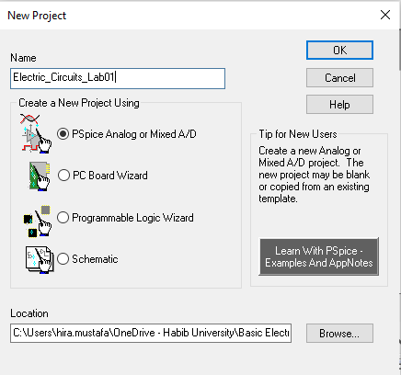
Figure 1.2
- A dialog opens as shown in figure below that asks if you would like to create a blank project or start a new one based on an existing project. Since there is no existing project, you should choose “Create a blank project”.

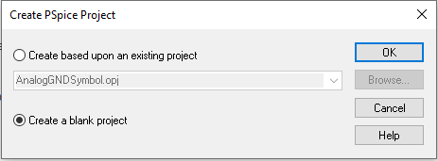
Figure 1.3
- A new project has been created, now, a window will appear where you are going to create your first circuit.

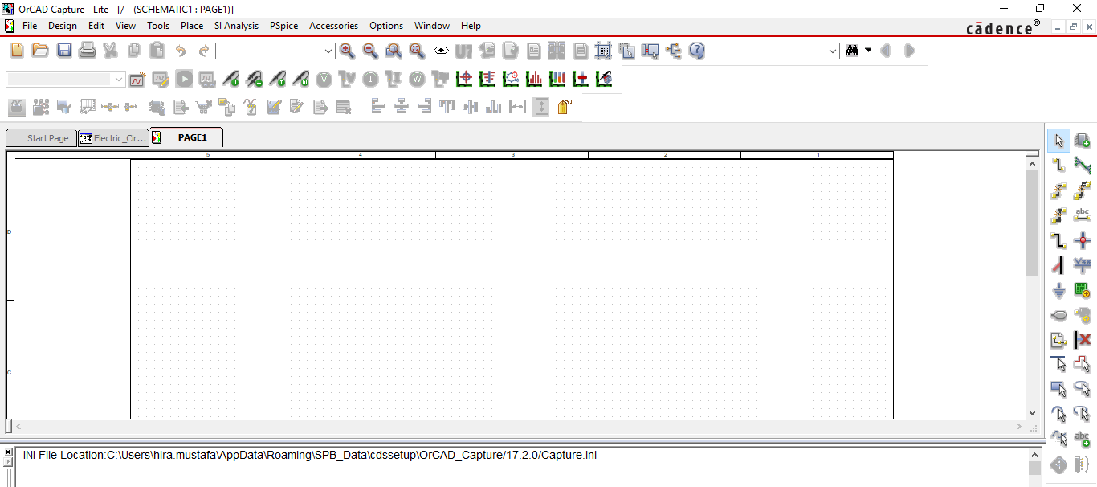
Figure 1.4: Environment of OrCAD PSpice
- In order to simulate a circuit first step is to draw the schematic, this can be done by placing the components on the empty space provided. For this there is an option Go to “Place Part” a small window will open, now Libraries need to be added so that components may start appearing on the Part List.

Click the “Add Library” icon refer Figure below for the icon and a window will pop up. Select all the Libraries by pressing “Ctrl + A”, once all the libraries are selected Click Open.

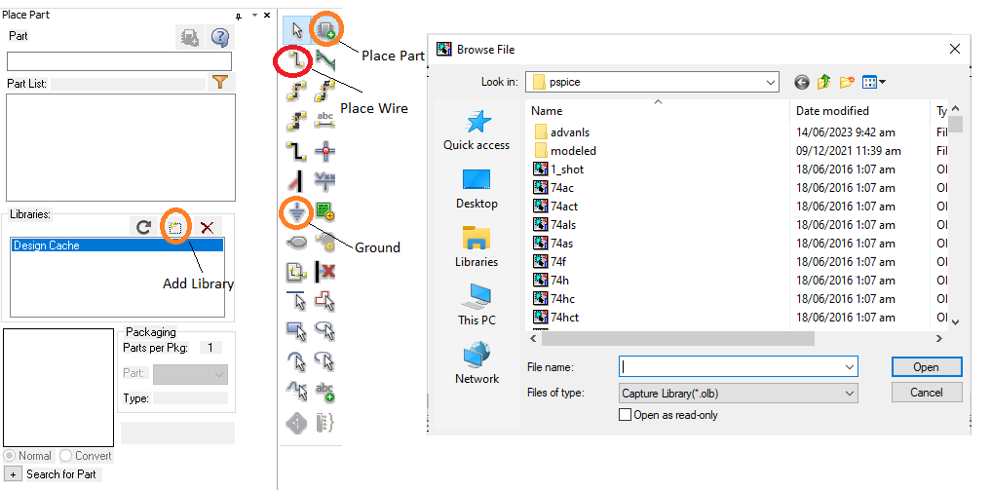
Figure 1.5: Place Part
- Here is the list of standard components that will be required in today’s Lab.
Table 1.2
Component Name | Component Name in PSpice
Resistor | R/ANALOG
Capacitor | C/ANALOG
Inductor | L/ANALOG
Diode IN4001 | 1N4001
Simple DC Voltage Source | VDC/SOURCE
Simple Voltage Source; AC, DC, Or Transient may be Specified | VSRC/SOURCE
Ground | 0/CAPSYM
DC Current Source | ISRC
VSIN | Transient sine Voltage Source
V_PULSE | Pulse Voltage Source
VAC | Simple AC Voltage Source

Introduction to PN-Junction Diode
The diode is a device formed by a junction of n-type and p-type semiconductor material. The lead connected to the p-type material is called the anode and the lead connected to the n-type material is the cathode. In general, the cathode of a diode is marked by a solid line on the diode. As a diode is formed from n- type and p- type semiconductor, there exist many electrons in n-type material whereas p-type material has many holes. When these two materials are combined, electrons of n-type material that are close to the junction fill the holes of p-type material closer to the junction. Consequently, the region of n-type material near the junction is turned into positive ions and the region of p- type material near the junction is turned into negative ions. Thus, in the region close to the junction, the carriers (electrons and holes) are depleted, whereas only positive and negative ions can exist. This region is referred to as “Depletion Region”. The force that prohibits the electrons and holes from passing the junction due to the effect of ions in the depletion region is referred to as “barrier voltage”. The typical barrier voltage in the p-n junction of germanium (Ge) is around 0.2-0.3 V, whereas it is around 0.6 V for silicon (Si). Formation of depletion region is illustrated in Figure 1.6.
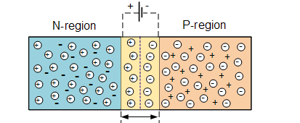
Figure 1.6: Depletion region at PN-junction of diode
A PN junction diode conducts only in one direction. The V-I characteristics of diode is a curve between voltage across the diode and current through it. When external voltage is zero, circuit is open and the potential barrier does not allow the current to flow. Therefore, the circuit current remains zero. When p-type (anode) is connected to positive terminal and n- type (cathode) is connected to negative terminal of the supply voltage, the biasing is known as “forward bias”. The potential barrier is reduced when diode is in the forward biased condition. At some forward voltage, the potential barrier is altogether eliminated and current starts flowing through the diode in the circuit. The diode is said to be in ON state. The current increases with increasing forward voltage. When n-type (cathode) is connected to positive terminal and p-type (anode) is connected to negative terminal of the supply voltage, the biasing is known as “reverse bias” and the potential barrier across the junction increases. Therefore, the junction resistance becomes very high and a very small current (reverse saturation current) flows in the circuit. The diode is said to be in OFF state. This reverse bias current is due to minority charge carriers.
Fill the table below with the respective forward Voltages of Ideal, Si and Ge diodes.
Table 1.3: Forward Voltages of diodes
Diode | Forward Voltage (Volts)
Ideal diode | 0
Silicon diode | 0.7
Germanium diode | 0.3

Task 2: To investigate VI-characteristics of Silicon diode
- Implement the circuit shown in Figure 1.7 using OrCAD Capture. Construct this circuit on PSpice. Start the circuit definition by placing some resistors as you desire to make a circuit. Select “Part” from the “Place” menu to open a dialog that allows you to choose the part you want to use. Parts are kept in various “libraries” for example, sources are in the SOURCE library and as we have already added all the libraries, we can simply write part name in the search bar and use the part. Refer Table 1.1.
- When you are satisfied that you have the right part, double click on the “R” item in the list. You will be returned to the drawing window. The symbol of a resistor will be attached to the cursor. Drag it to a point towards the left side of the drawing window and click the left mouse button to “place” it. The resistor will have default name of “R1” and a default value of 1k (1 Ω).
- When finished with the resistor, click the right mouse button and choose “End mode” from the popup menu or hit the escape key to get rid of the resistor attached to the cursor. If you don’t like the location of a resistor, you can select it and drag it to a new spot.
- To change the value of a component, double-click on it which opens a new window. In value field, type the required value of component, and select OK. To change the orientation, right-click the mouse and choose “rotate” from the pop-up list.
- Here, a diode model 1N4001 is connected to a DC voltage source through a resistor. From the datasheet of 1N4001 diode model, you can verify that it is a Silicon diode. In order to add the diode library, select all the folders when adding libraries to PSpice, which includes: Advanls, modeled and all the other individual files.
- Use the same procedure to place a DC voltage source (“VDC” or “VSRC” in the source library) in the drawing window and set its value to 10V.
- Now that all parts are placed, we can use the wire tool to connect the them. Select the “Place Wire” item from the “Place” menu (or click on the second item on the left side of the vertical tool-bar) to activate the wire tool, refer Figure 1.5. The cursor turns into a cross-hair.
- Every PSpice circuit needs a ground connection. To add a ground, use the menu (Place → ground) or click on the “ground” item in the vertical tool-bar or press key G, refer Figure 1.5. A dialog opens. Choose the 0/CAPSYM. Place the ground in the desired place in the drawing and then use the wire tool to connect it into the circuit.
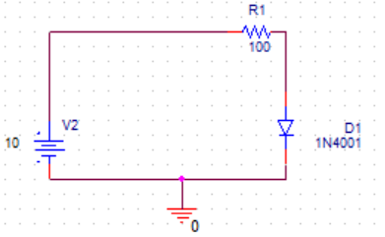
Figure1.7: Schematic for obtaining VI-characteristics of Silicon diode
- In PSpice when adding diode don’t get confused with D1N4001. Use 1N4001 diode. Both these diodes have different characteristics. This diode will be found in Advanls library you will have to open this folder and add all the libraries in this folder.

- Select a current marker from PSpice tool-bar and place it on the leg of an element (example first leg of Diode D1) where you want to monitor the amount of current flow. The complete schematic with marker placed on the diode is shown in Figure 1.8a.
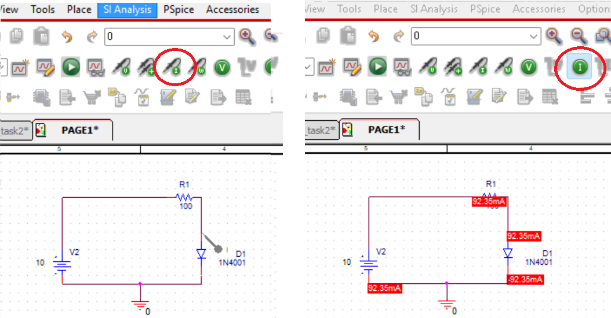
Figure 1.8a: Current Marker on the diode D1 Figure 1.8b: Current value of the branches
- Now that the circuit schematic is completed, you are ready to tell PSPICE how to analyze the circuit. From the “PSPICE” menu, select the menu item “New Simulation Profile” (or choose the first item in the second horizontal tool-bar). A small dialog appears that asks you to give a name to the simulation profile you are creating. Choose a clever name like “sim_diode_task1” and click on “Create”.

- Another dialog with many tabs appears. The only tab that is important at this point is the one labeled “Analysis”. It is important to understand the different analysis types, which are selected using the pop-up menu under the heading “Analysis Type”.

- There are four options in that menu:
- Bias point: This calculates the DC values for all the node voltages and branch currents in the circuit. This corresponds to using the DC multi-meter to probe each voltage and current in the circuit. When using this option, the voltages and/or currents will be displayed directly on the circuit diagram.


- We usually do not use current markers for DC voltages, only select the analysis type to BIAS POINT and you can run the simulation. The voltages or currents will directly appear on the circuit diagram, it is necessary to specify which parameter you want to have displayed. Values of current for the circuit under observation have been displayed on the circuit diagram, Refer Figure 1.8b and observe that the option of current has been selected.

- DC Sweep: Similar to bias point, expect that the value of one DC source in the circuit can be varied over some range, and the currents and voltages in the circuit are calculated at each DC source value. This allows you to make a plot of a voltage or current in the circuit as a function of the DC source voltage.
- AC Sweep: This uses a constant amplitude AC source whose frequency can be varied over some range. The AC (complex) voltages and currents are calculated at each frequency. This allows you to make a plot of the magnitude and/or phase of any voltage or current in the circuit as a function of frequency.
- Time Domain (Transient): This calculates the currents and voltages in a circuit at various points in time, allowing you to make a plot of a voltage or voltage as a function of time. The resulting plot would correspond to what you might see on the oscilloscope if you were measuring the circuit in lab. Each of the analysis options requires the proper choice of source(s) in the circuit. (This is why there are so many different source options). Obviously, the DC analysis require DC source, VDC and IDC being the most common. The AC sweep uses the VAC or IAC sources, for which only the amplitude is specified. Time domain analysis requires sources whose time behavior is well specified, and so there are more options and the sources themselves require more parameters. Two of the more commonly used time domain sources are VSIN, which is a sine function, with specified amplitude and frequency and VPULSE, which is a square wave requiring a number of parameters to define the shape of the pulse.

*The summarized details of the simulation options along with its application is provided in the Appendix of this Lab.

- To obtain VI-characteristic curve, the source voltage is varied and current through the diode is measured along with the voltage appearing across it. Practically, the supply voltage is varied using variable DC supply. In PSpice simulation, DC source voltage can be varied using DC Sweep option.
- Drop down the options in Analysis Type and select DC Sweep. Click “Ok”, refer to the Figure below.
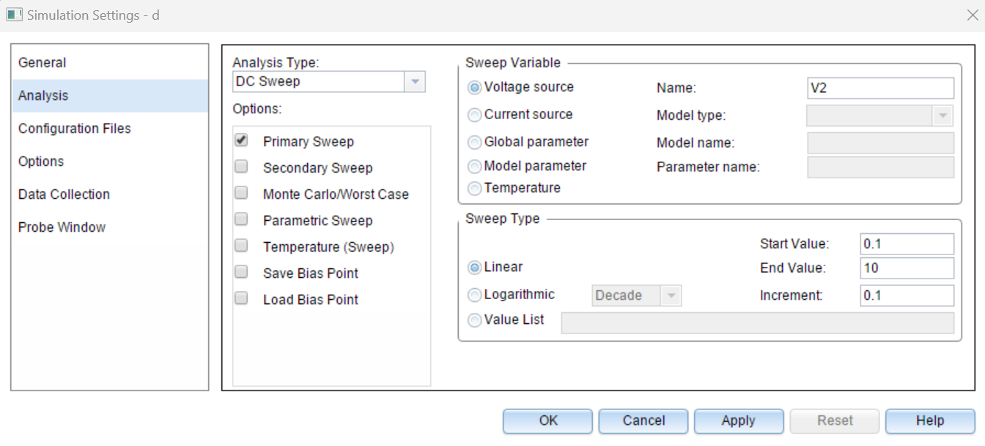
Figure 1.9: DC Sweep Simulation Settings

- To perform sweep analysis, create a new simulation profile. New Simulation Profile option can be found under PSpice in Menu bar above or from shortcut icon. From Simulation Settings window, in Analysis Type select DC Sweep option. Under Sweep Variable, select Voltage Source and write down the name of voltage source used in circuit e.g., in Figure 1.7 the source model name is V2. In Sweep Type, select Linear. To sweep voltage from 0.1 to 10V at an increment of 0.1 V, enter corresponding Start Value, End Value and Increment. Apply the selected settings.

- Now, place a current marker to measure diode current entering the anode terminal, refer figure 1.8b. Run the simulation, refer Figure 1.10. A plot for anode current will be displayed. By default, the x-axis variable of sweep analysis simulation is the sweep variable i.e., source voltage. But VI-characteristic curve is plot of diode current as a function of anode-to-cathode voltage. To change x-axis variable, go to Plot > Axis Settings. In X-Axis tab, select Axis Variable. The trace for anode to cathode voltage should be added in Trace Expression. If the diode model name is D1, under Simulation Output Variables the anode voltage expression will be V(D1:1) or V(D1:AN). It’s important to understand the trace expressions. The first alphabet is measurement (V-voltage, I-current), then in brackets the component name is followed by its terminal (D1-diode model name in our schematic, and terminal 1 or AN-anode is specified with it after colon). The anode to cathode voltage expression can be added as: V(D1:AN) – V(D1:CAT).

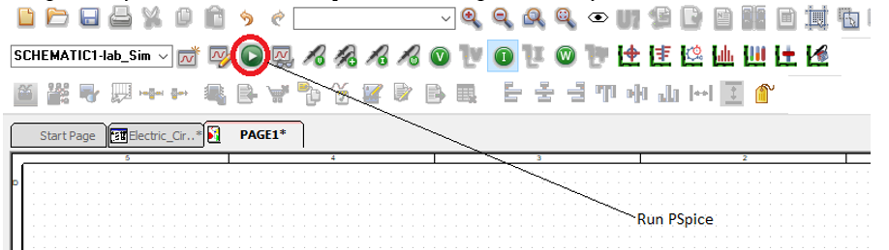
Figure 1.10: Run Simulation

- The plot obtained is the characteristic curve of Silicon diode in forward biased region. Attach capture of the plot and analyze the relation between voltage and current as represented by curve.
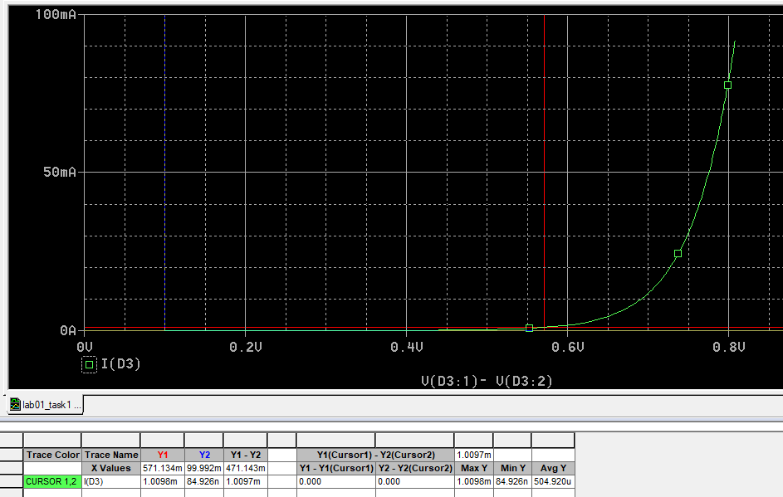
- From curve, find the value of forward voltage across diode when current through it reaches 1mA. You can add cursor in your plot window by selecting Toggle Cursor option from the shortcuts just above the plot. The value of x-axis and y-axis variable of curve intersecting the cursor will be displayed at the bottom right of the window.
Forward voltage across Si diode | 0.571V
- To obtain the VI-characteristic curve in reverse biased mode, now reverse the connections of diode i.e., cathode connected to higher potential and anode connected to ground. In reverse biased mode, now sweep the voltage from 0.1 to 150 V. Obtain the plot of current through anode as a function of diode voltage.

Note: Make sure that the current marker is placed at anode terminal and x-axis variable is diode voltage measured from anode to cathode.

- Analyze the obtained plot and attach its capture.
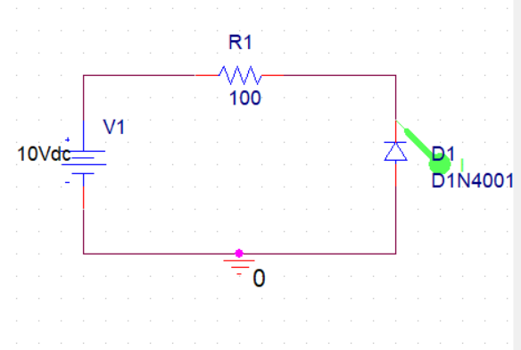
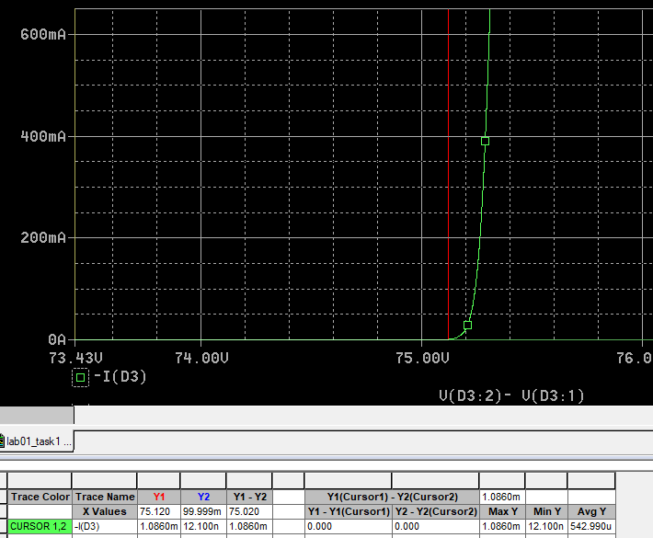

Task 3: To investigate VI-characteristics of Germanium diode
- In OrCAD Capture Lite, there isn’t any model of Germanium diode in available libraries. To add a model for Germanium diode, follow the given steps.
- Search for model Dbreak and place it in your schematic. Right click the model and select Edit PSpice Model. This will take some time to communicate with server and open PSpice Model Editor Window. You can see that under Model Name Dbreak is mentioned. Paste the given parameters in the window at right. These parameters are model specific (for Germanium Diode model 1N34A) and can be searched from respective datasheet.
Where, bv is reverse breakdown voltage, cjo is zero-bias junction capacitance, eg is activation energy, ibv is reverse breakdown current, is is saturation current, rs is parasitic resistance (series resistance), n is emission coefficient, vj is junction potential and m is junction grading coefficient.
.MODEL 1N34A D (bv=75 cjo=0.5e-12 eg=0.67 ibv=18e-3 is=2e-7 rs=7 n=1.3 vj=0.1 m=0.27)
- After adding the given parameters, you will notice that model name is changed to 1N34A. Save the model and close editor. This will add a diode library with .lib extension in your project folder. To add this library, go to Edit Simulation Profile. In Configuration Files tab, under Category select Library. Browse the .lib file recently added in your project folder and Add to Design. The diode model 1N34A can now be used.

- Use this Germanium diode and obtain its VI-characteristic curve in forward bias and reverse bias mode by following the steps in Task 2. Find the forward voltage across Ge diode.
Forward voltage across Ge diode  Reverse voltage across Ge diode | 293.29mV  -74.93V
- Analyze the obtained plots and compare them with the characteristic curve of Silicon diode. Attach capture of the obtained plots.
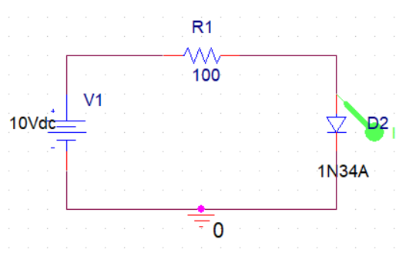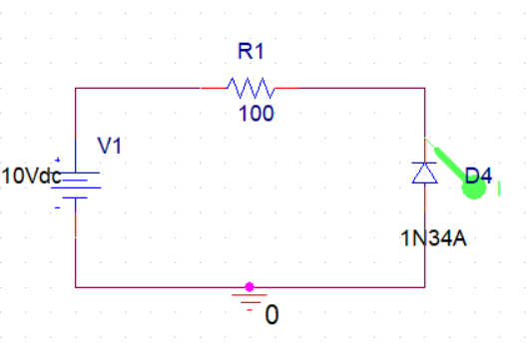
Forward:
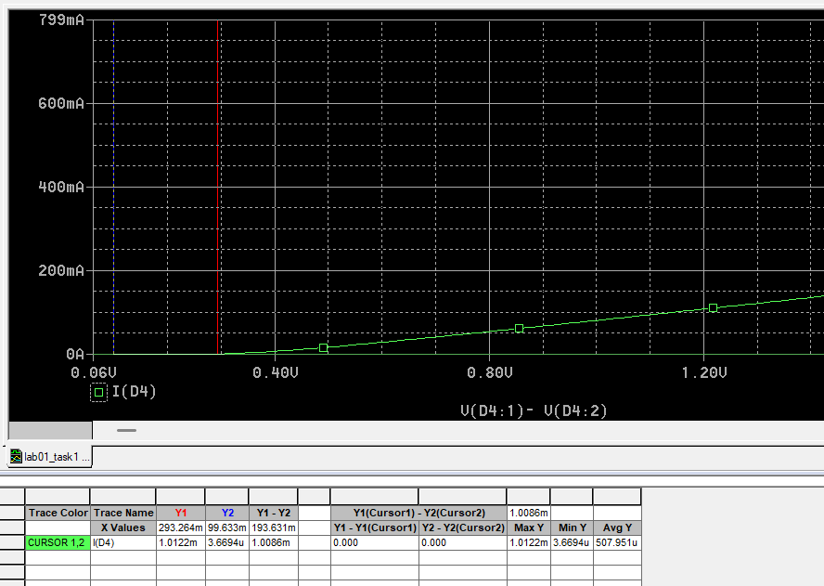
REVERSED:
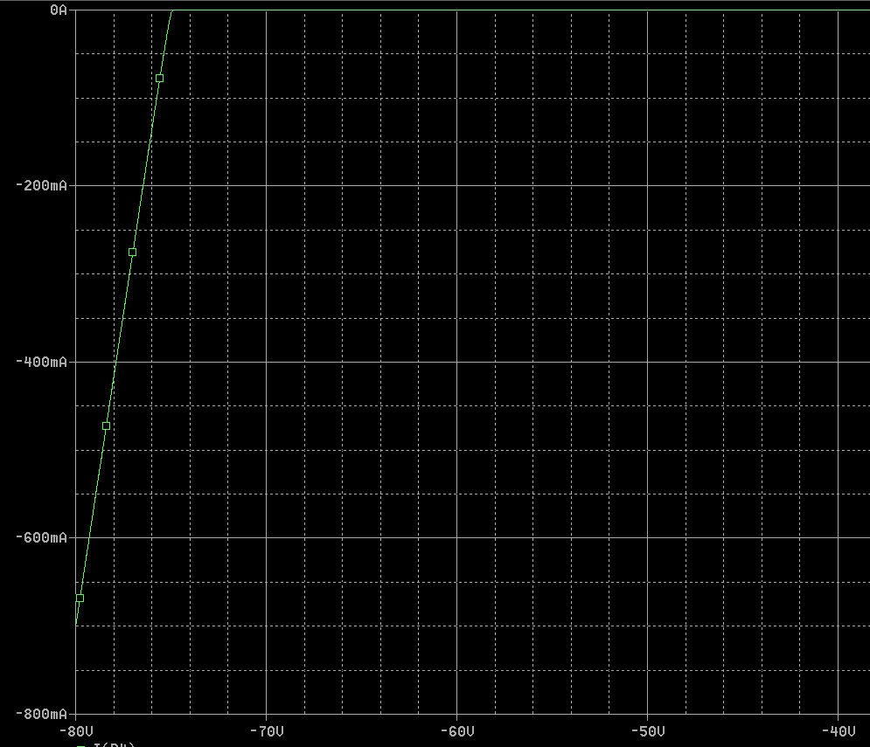

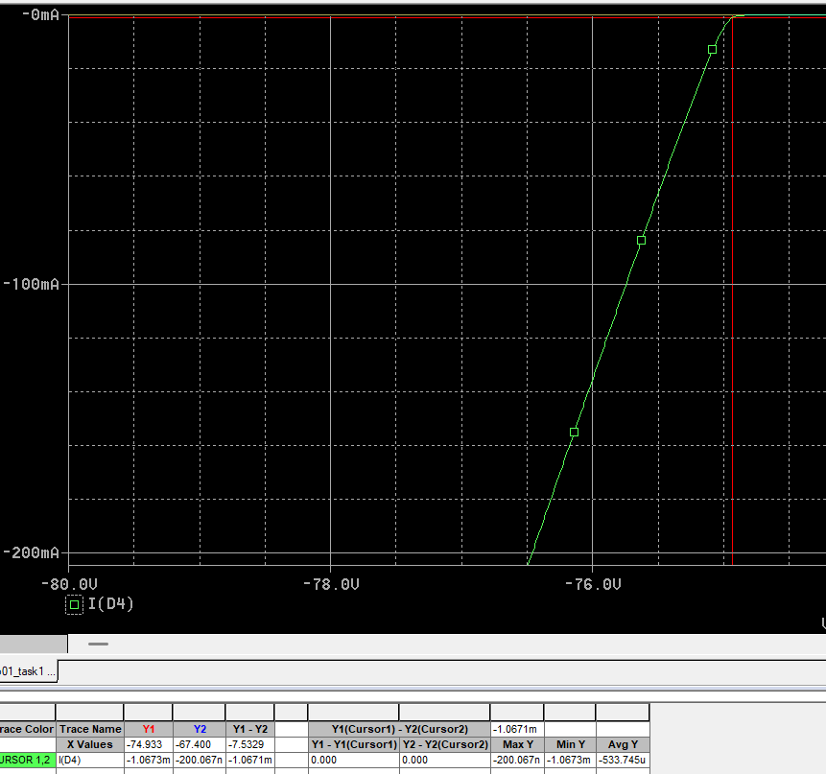

Task 4: To investigate the working of series connected diode in a circuit
- For the circuit shown in Figure 1.11, calculate the current through diode Id and output voltage V_{O} by applying basic circuit laws and fill in Table 1.4. Use V_{D} (forward voltage drop across Si diode) found in Task 3. Show calculations in the box below:

Calculations:
Applying KVL
$$5=Id(2.2k+1k)+0.293 \\ 5-0.293=Id(3200) \\ Id=4.707/3200 \\ Id=0.001471\text{ A} \\ I=1.47\text{ mA}$$
Output Voltage Vo across R2:
$$Vo=Id×R2 \\ Vo=(1.471\text{ mA})(1000) \\ Vo=1.47\text{ V}$$

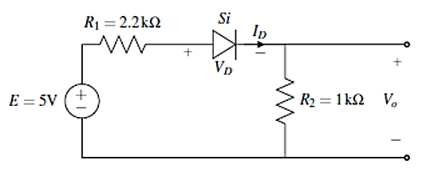
Figure 1.11: Schematic for circuit of task 4
Table 1.4: Output voltage and current of the circuit shown in Figure 1.4
Quantity | Calculated Results | Simulated Results
Diode Current I_{D} | 1.47mA | 1.39mA
Output Voltage V_{O} | 1.47V | 1.399V
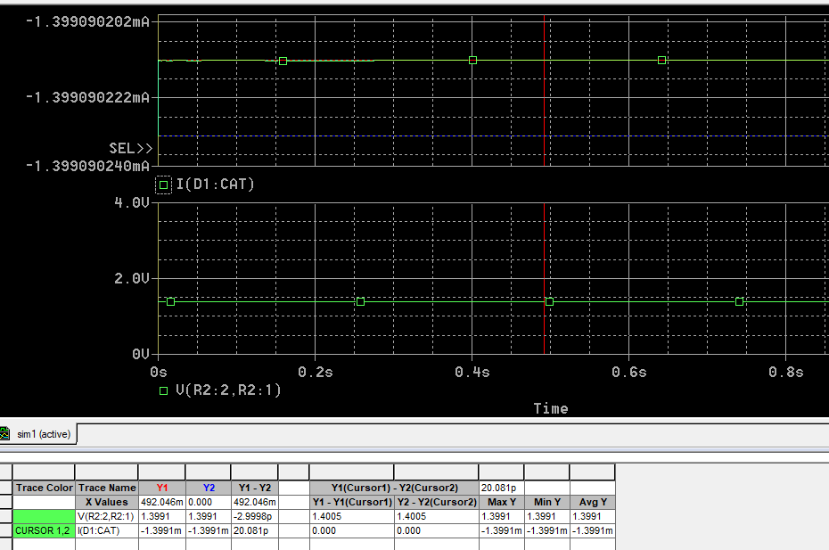
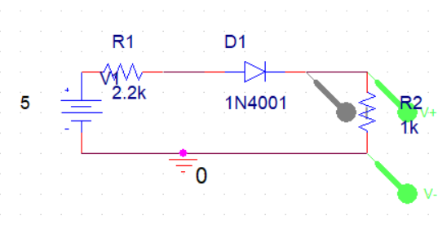
- Implement the circuit using OrCAD Capture. To simulate a DC circuit, you can simply perform Bias Point analysis and obtain values of voltage and current at different points of the circuit which get displayed on diagram when bias point voltage and current display are enabled using these icons.

You can find these DC values through transient analysis as well by obtaining graph of DC voltage and current with respect to time. These graphs will be straight lines as DC values remain constant with respect to time. Using transient analysis, voltage and current plots should always be displayed in separate plots as current is usually in mA. Therefore, same y-axis scale is not suitable for display.

- Obtain the simulated results for voltage and current by Bias Point or Transient analysis. Fill in Table 1.4 and verify the calculated results.

Task 5: To investigate the working of a circuit with parallel connected diode
When there are two diodes connected in parallel the one which requires least potential or it can be said that the one which provides least resistive path turns ON and enables the current to pass through whereas the other remain OFF.

- For the circuit shown in Figure 1.12, predict the output voltage V_{O}. (Consider the forward diode voltages of the two diodes as found in Task 3 and Task 3.) And write your answer in Table 1.5. You may use the box below to show the working if any

The output voltage will be around 0.3v as germanium diode will pass the current at 0.3v and silicon diode will remain off, so voltage across germanium and Vo will be around 0.3v.
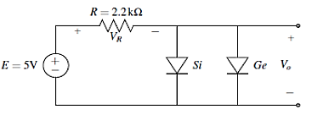
Figure 1.12: Schematic for task 5 where Si and Ge diode are in parallel
- Simulate the same circuit using PSpice and find out output voltage and current through the 2 diodes. Fill in 5.

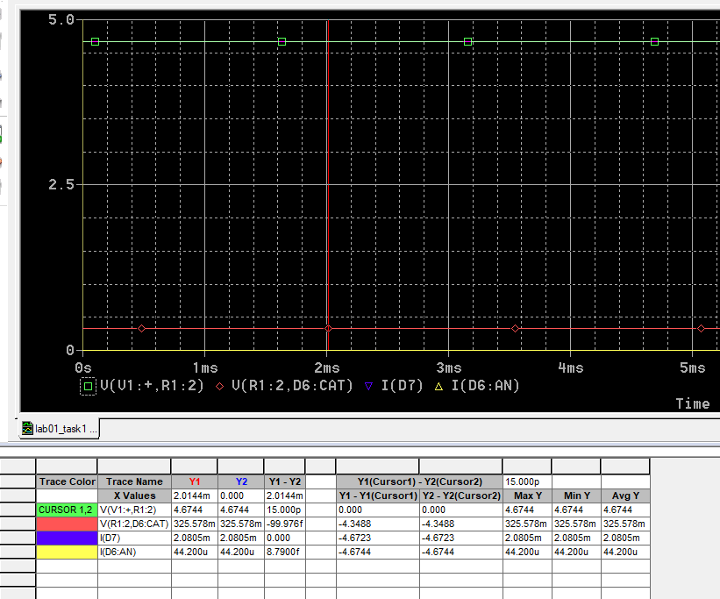
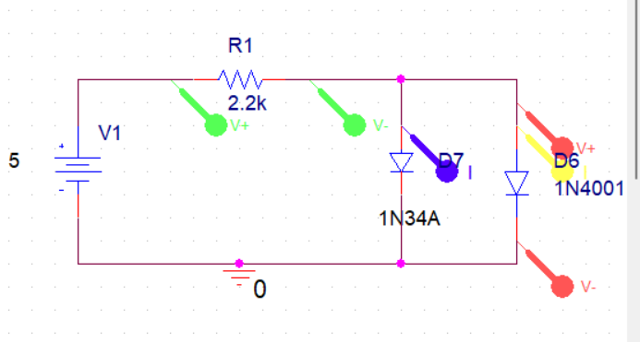
Table 1.5: Data table for the circuit of Figure 1.5
Predicted Output Voltage V_{O} | 0.3v
Simulated Output Voltage V_{O} | 0.326v
Si Diode Current I _{Si} | 44.2uA
Ge Diode Current I _{Ge} | 2.11m

- After investigation of voltage and currents, what do you conclude about parallel connection of diodes?
The diode will the lowest forward voltage will turn on first and diodes with higher forward voltage will remain off, which means that current will only pass through the diode with lower forward voltage in our case it was germanium diode with the forward voltage of 0.3V
- Now, replace the Germanium diode in above simulated circuit by a 1k Ohm resistor as shown in Figure 1.13. Predict the output voltage and verify it by simulating the circuit using PSpice. Fill in the results in Table 6.
- 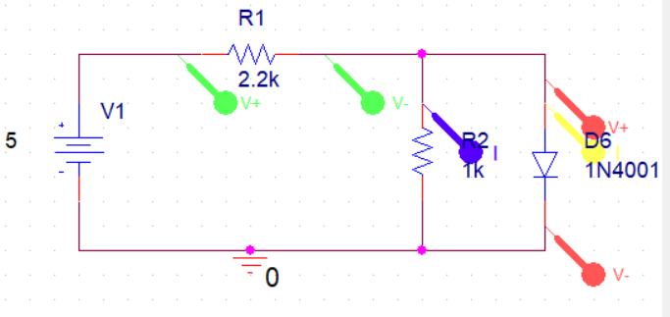
- 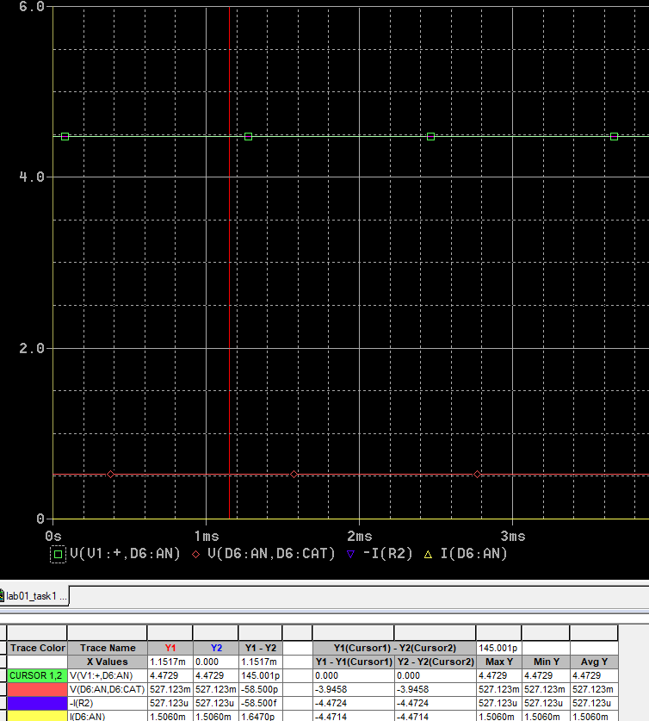
Table 1.6: Output voltage of the circuit shown in Figure 1.10
Predicted Output Voltage V_{O} | 0.6V
Simulated Output Voltage V_{O} | 590mV
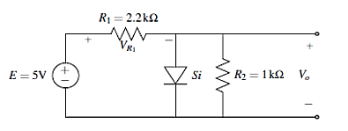
Figure 1.13: Schematic for task 5 with diode connected in parallel to a resistor

Introduction to Zener Diode
A Zener diode is a silicon PN junction device which allows current to flow in the forward direction in the same manner as an ideal diode, but will also permit it to flow in the reverse direction when the voltage is above a certain value known as the “Breakdown Voltage”, “Zener knee voltage”, “Zener voltage” or “avalanche point”. The breakdown voltage of a Zener diode is set by carefully controlling the doping level during manufacture. The symbol for a Zener diode is shown in Figure 1.14. Instead of a straight line representing the cathode, the Zener diode has a bent that reminds you of the letter Z (for Zener).
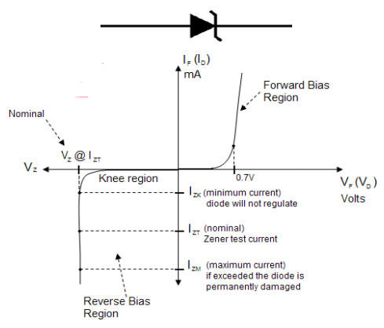
Figure 1.14: Symbolic representation and VI curve of a Zener diode
Avalanche breakdown and Zener breakdown are the two different mechanisms due to which the conduction of Zener diode in reverse bias mode becomes possible. The main difference between Zener breakdown and avalanche breakdown is their mechanism of occurrence. Zener breakdown occurs because of the high electric field. The avalanche breakdown occurs because of the collision of free electrons with atoms.
Both these breakdowns can occur simultaneously. Either of these effects, or a combination of the two, significantly increases the current in the reverse bias region while having a negligible effect in the voltage drop across the junction. The Zener process is not inherently destructive unless the maximum power dissipation specified for the device is exceeded. V-I Characteristics Curve of Zener Diode is shown in Figure 1.14. The right half side of the characteristics curve is the part in which the Zener diode receives forward voltage. In left half side of the characteristics curve the diode is in reverse biased. At first, when reverse voltage is applied, the current is very small, which is called the leakage current, flowing through the diode. Once it hits the breakdown voltage, the current drastically increases. This current is called the avalanche current, because it spikes drastically up. The breakdown voltage point is also important, not just because of the avalanche current, but more importantly because once the voltage of the Zener diode has reached this point, it remains constant at this voltage, even though the current across it may increase largely. This makes the Zener diode useful in applications such as voltage regulation.

Task 6: To investigate VI-characteristics of Zener Diode
- Implement the circuit shown in Figure 1.15. To obtain the VI-characteristic curve of Zener diode (model 1N4740A) in forward biased region, sweep the DC voltage source from 0 to 10V. Obtain the curve of current through anode terminal of Zener diode as a function of voltage across Zener diode (measured from anode to cathode). Make sure that the x-axis variable is set accordingly. Attach graph capture of obtained plot.
- Be careful when selecting the diode in PSpice there is model 1N4740 as well which has different properties do not go for that one, the right one is 1N4740A .
Figure 1.15: Schematic of circuit for Zener diode characteristics
- Now, connect the Zener diode in reverse polarity. To obtain VI-characteristics in reverse biased region, again sweep the DC voltage from 0.1 to 30V and obtain plot of anode current as a function of voltage across Zener diode measure from anode to cathode. Attach graph of the obtained plot.
- Analyze the VI-characteristics of Zener diode and compare the plot in forward biased and reverse biased region.
Forward Biased
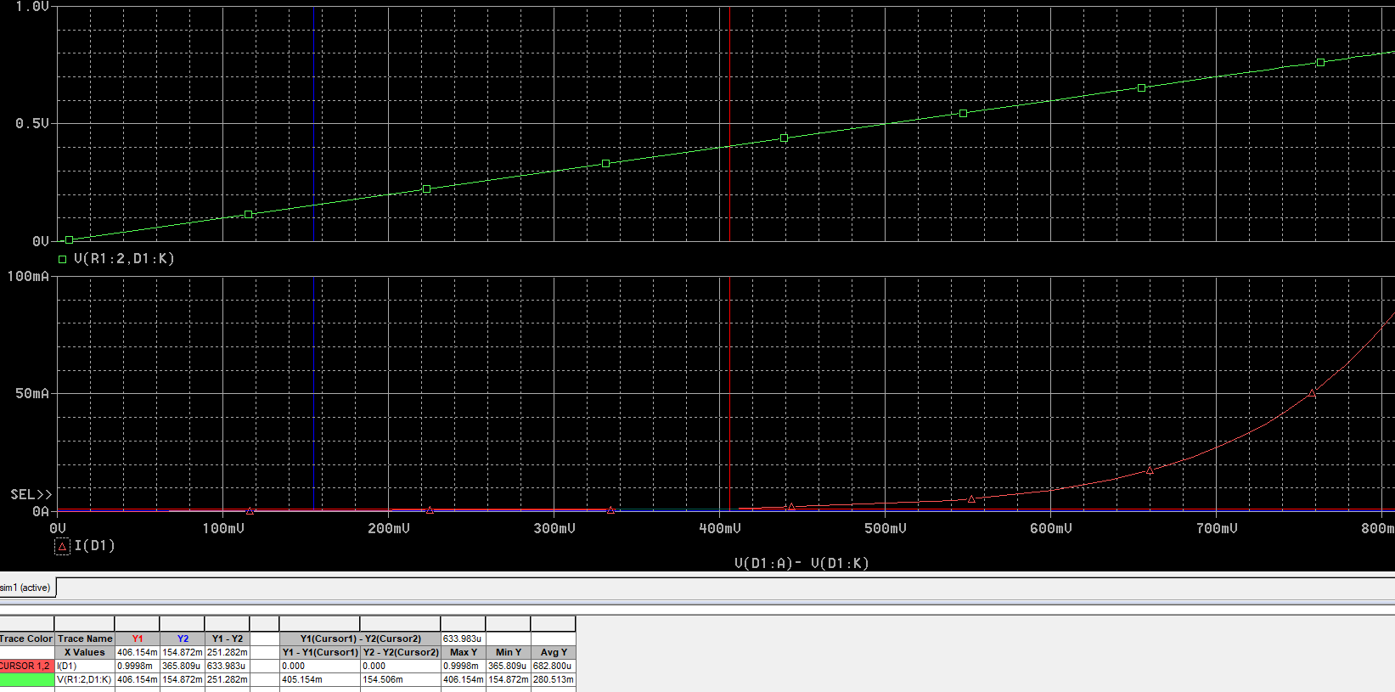
Reversed biased

REVERSED Biased:_
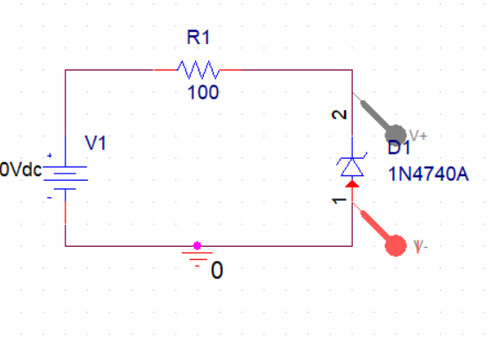
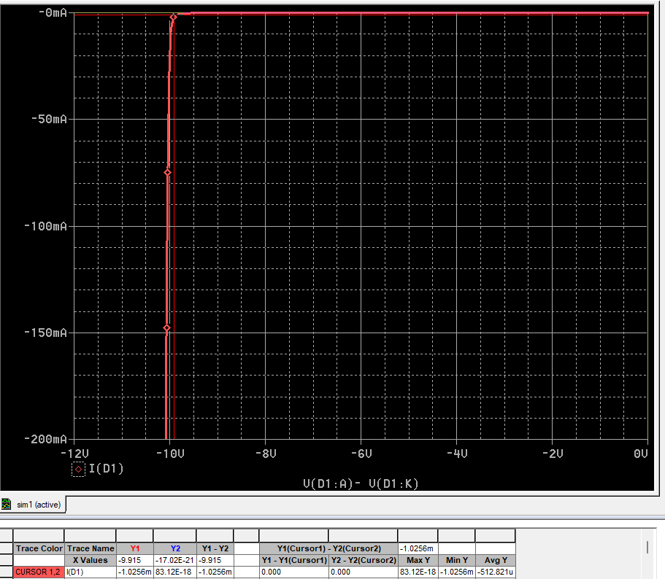

- From the characteristic curves, what is the value of Zener Voltage V_{Z} for Zener diode 1N470A?

Zener Voltage of 1N470A: V_{Z} | In Forward Bias: 0.406V  In Reverse Bias: 9.91V

Task 7: To investigate the application of Zener diode for voltage regulation
- Consider the circuit shown in Figure 1.16 where E = 15V, R₁=1kΩ and R_{L}= 1kΩ.
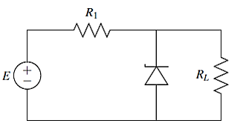
Figure 1.16: Schematic for task 7
- Calculate the voltage across R1 and R_{L} without considering Zener diode in the circuit. Now, if Zener diode is connected here, will it operate in breakdown region? Assume Zener voltage as found in previous task. Fill in Table 1.7.
- Simulate the circuit with Zener diode. Verify your results and complete the respective column in Table 1.7.

Table 1.7: Data Table for investigating Zener diode application
Estimated Values
Parameter | R_{L}=1 kΩ | R_{L}=3.3 kΩ
Voltage across R₁: V₁ | 7.5v | 3.49
Voltage across R_{L:} V_{L} | 7.5v | 11.51
Operation region of Zener diode | off | on
Simulated Results
Voltage across R₁: V₁ | 7.50 | 5.06
Voltage across R_{L:} V_{L} | 7.49 | 9.93
Current through Zener Diode: I_{Z} | 9.5uA | 2.053mA
Operation region of Zener diode | no | yes

- Now, repeat the above 2 steps and predict the operation of Zener diode when load resistor is 3.3kΩ. Verify your calculations through simulated results. What do you conclude from the results of above 2 cases? Why the load voltage is not equal to the calculated value in the presence of Zener diode when load resistor is changed to 3.3kΩ?
he calculated voltage across the load without the Zener diode is 7.5V. Since this voltage (7.5V) is less than the Zener breakdown voltage (9.91V), the Zener diode remains in the off state and acts as an open circuit. The simulated results confirm this, showing V₁ = 7.50V and V_L = 7.49V (nearly identical to calculated values), with a very small leakage current of 9.5μA through the Zener diode. This small current indicates the diode is not conducting significantly and remains off.
However, when R_L is changed to 3.3 kΩ, the situation changes dramatically. The calculated voltage across the load without the Zener diode is 11.51V, which exceeds the Zener breakdown voltage of 9.91V. In this case, the Zener diode enters the breakdown region and begins conducting. The simulated results show that V_L = 9.93V (very close to the Zener voltage) instead of the calculated 11.51V, with a significant current of 2.053mA flowing through the Zener diode. The voltage across R₁ also changes to 5.06V (instead of the calculated 3.49V) because the Zener diode now clamps the load voltage and diverts excess current.

- Analyze the application of Zener as voltage regulator.
A Zener diode functions as a simple and effective voltage regulator by maintaining a constant output voltage across the load. When the voltage across the Zener exceeds its breakdown voltage (V_Z), it enters the breakdown region and conducts current while keeping the voltage nearly constant at V_Z. When load voltage < V_Z: Zener is off, no regulation occurs, When load voltage > V_Z: Zener conducts, regulates output to V_Z

- Determine the minimum value of R_{L} required to ensure that the Zener diode remains in the “on” state and therefore, maintains the output voltage equal to the Zener voltage. Show calculations.
When the Zener is regulating, the voltage across R_L (and the Zener) is:
$$V_{L}=V_{Z}=9.91V$$
Voltage across R₁:
$$V_{R1}=E-V_{Z}=15V-9.91V=5.09V$$
Total current through R₁:
$$I_{R1}=\frac{V_{R1}}{R_{1}}=\frac{5.09V}{1kΩ}=5.09mA$$
This current splits into two paths:
$$I_{R1}=I_{L}+I_{Z}$$
For the Zener to remain "on":
$$I_{Z}≥I_{Z(min)}=1mA$$
$$I_{L}≤I_{R1}-I_{Z(min)} \\ I_{L}≤5.09mA-1mA=4.09mA$$
Minimum R_L:
$$R_{L(min)}=\frac{V_{Z}}{I_{L(max)}}=\frac{9.91V}{4.09mA}=2.42kΩ$$

Post Lab Tasks

Task 8: To investigate the characteristics of LED as diode
Is LED a diode? Justify your answer by obtaining VI-characteristic curve of LED? To add a model of LED in PSpice, go to Place> PSpice Component > Modeling Application > Diodes > LED.
Yes, an LED is a diode. LED stands for Light Emitting Diode, which is a semiconductor device that allows current to flow primarily in one direction, just like a conventional diode. The key difference is that when an LED is forward biased and current passes through it, it emits light due to the recombination of electrons and holes at the PN junction. This property makes LEDs widely used for indication, display, and lighting purposes, while still retaining the fundamental electrical behavior of a diode.As from the table we can see as the voltage risies above the threshold reverse biased voltage (5V in this case) led starts to pass the current. And for forward biased, it starts to pass current at (2.7 volts) its threshold voltage.

I-V CHARACTERSTIC TABLE (reverse biased):
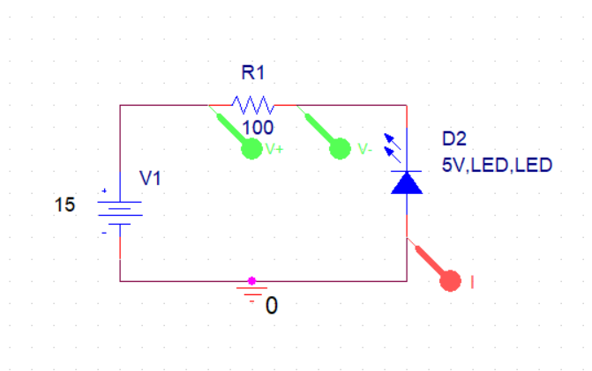
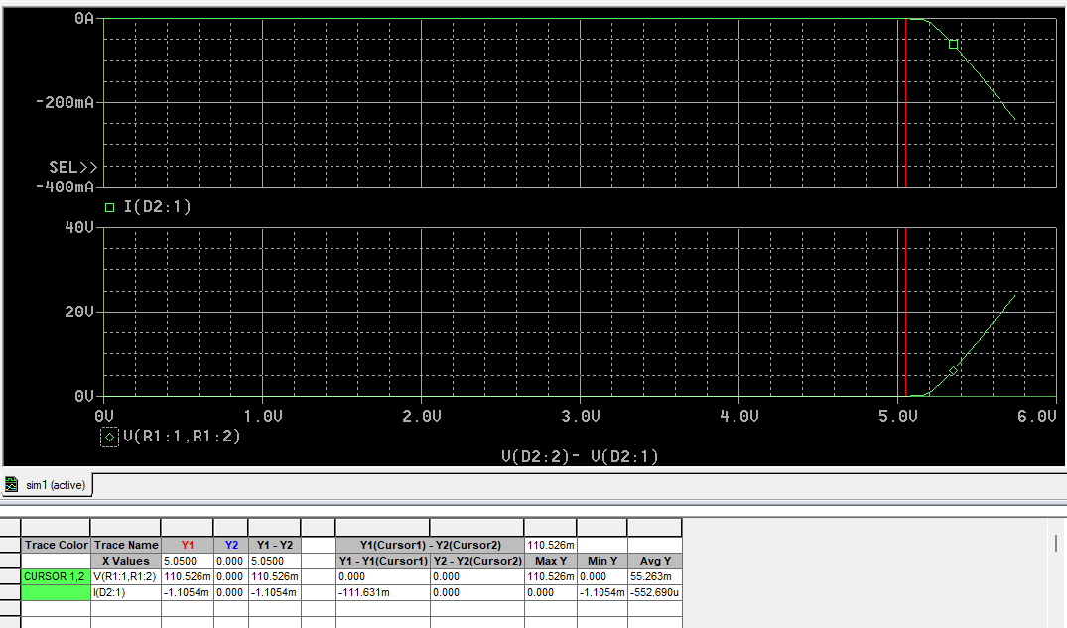

IV CHARACTERSTIC (forward biased):
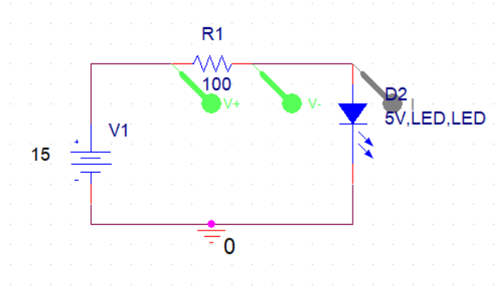
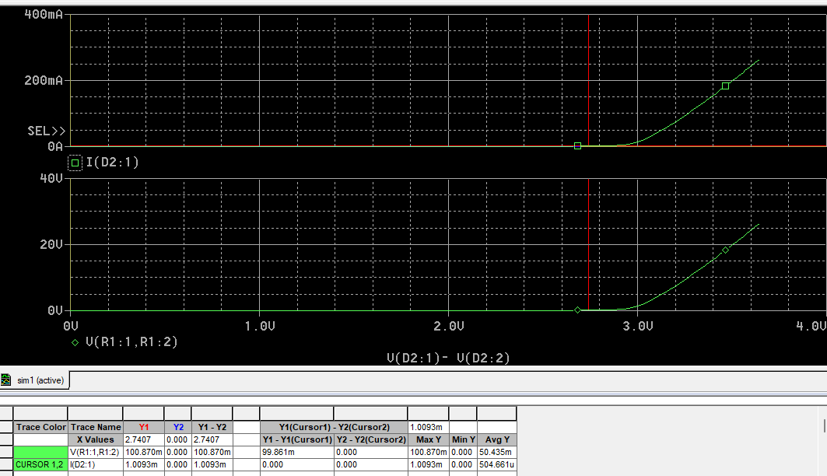

Appendix: Guide to PSpice
Analysis Types in PSpice: Analysis types PSpice can be applied to perform include DC analysis, AC analysis, transient analysis and advanced analysis. Each type of analysis contains their own analysis types that are shown in the following table.
DC Analysis | DC sweep analysis | To sweep a source, a global parameter, a model parameter or the temperature via a range of values.
DC Analysis | Bias point analysis | To implement any analysis.
DC Analysis | DC sensitivity analysis | To calculate and report the sensitivity of one node voltage to each device parameter.
AC Analysis | AC sweep analysis | To calculate small-signal response.
AC Analysis | Noise analysis | To calculate and report device noise and total output and equivalent input noise.
Transient Analysis | Parametric analysis | To perform multiple iterations of a specified standard analysis.
Transient Analysis | Temperature analysis | To return standard analyses set in the Simulation Settings dialog box at different temperatures.
Transient Analysis | Monte Carlo analysis | To calculate the circuit response to changes in part values.
Advanced Analysis | Worse case analysis | To find the worst probable output of a circuit or system.

FAQs
Q. Difference between VAC and VSIN?
Ans: VAC is used for primarily AC analysis, while VSIN can be used for both sin and transient analysis. VSIN allows you to set offset, frequency in addition to peak voltage.

Assessment Rubric
Lab 01
Characteristics of Diodes
Name: | Student ID:

Points Distribution

Task No. | LR2  Simulation  24 | LR 4  Data Collection  14 | LR5  Plots  16 | LR 6  Calculation  12 | LR 10  Analysis  26
Task 1 | /4 | /4 | - | -
Task 2 | /4 | /2 | /4 | - | /4
Task 3 | /4 | /2 | /4 | - | /4
Task 4 | /2 | /2 | - | /4 | -
Task 5 | /2 | /2 | - | /4 | /2
Task 6 | /4 | /2 | /4 | - | /4
Task 7 | /4 | /4 | - | /4 | /4
Task 8 | /4 | - | /4 | - | /4
Total | /28 | /14 | /16 | /12 | /22
CLO Mapped | CLO 3 | CLO 3 | CLO 3 | CLO 3 | CLO 3

Affective Domain Rubric |  | Points | CLO Mapped
AR 4 | Report Submission | /8 | CLO 3

CLO – (LDL) | Total Points | Points Obtained
CLO3 – (Psy-4) | 100
Total | 100

For description of different levels of the mapped rubrics, please refer the provided Lab Evaluation Assessment Rubrics and Affective Domain Assessment Rubrics.

In Order to select correct Ground on PSpice see the pallet on the right and click the symbol of GND. The PSpice circuits do not simulate without Ground being provided. Make sure to add ground in every circuit.
This is library for diode and some Transistors

